Single Sign On (SSO) - SAML

Introduction:

Pickup is a cab company that has many employees and different internal enterprise applications. Following are two such applications:
- Pickup Dispatch: This application helps manage the overall operations at Pickup.
- Pickup Manager: This application helps allocate vehicles to drivers.
Pickup is using WSO2 Identity Server as the identity provider for their applications.
Bob is a Pickup employee who usually forgets application passwords. As a result, Bob uses the same credentials for all the Pickup applications. However, due to busy schedules, Bob does not like entering the credentials at every login. So, the WSO2 Identity Server team suggested Bob to use Single Sign-On (SSO).
With SSO, Bob only needs to provide the login credentials to one Pickup application and automatically be logged in to other Pickup applications.
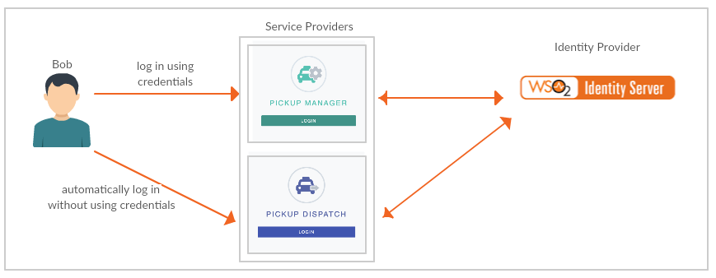
This tutorial will allow you to have hands-on experience on how to configure SSO with WSO2 Identity Server using SAML protocol.

Setting up:
- Set up Apache Tomcat 9:
  - Extract the Apache Tomcat 9 zip. The extracted folder is called <TOMCAT_HOME> below.
  - Make sure the JAVA_HOME environment variable points to your JDK (21 or 25).
  - Start Tomcat from <TOMCAT_HOME>/bin. It listens on port 8080:
Windows (Command Prompt):
cd <TOMCAT_HOME>\bin
catalina.bat start
Linux / macOS (Terminal):
cd <TOMCAT_HOME>/bin
sh catalina.sh start
  - Open http://localhost:8080 and check that the Tomcat page loads. To stop Tomcat, run catalina.bat stop (Windows) or sh catalina.sh stop (Linux/macOS) from the same folder.
- Get saml2-web-app-pickup-dispatch.com.war and saml2-web-app-pickup-manager.com.war from the SampleApps folder provided with this training and deploy them in Tomcat. These versions already contain the WSO2 Identity Server 7.3.0 keystore (wso2carbon.p12) and read claims through the REST API, so no keystore copy or extra server configuration is needed.
Note: If you use older versions of these samples from GitHub instead, change localhost.com to localhost in SAML2.AssertionConsumerURL in WEB-INF/classes/sso.properties, copy <IS_HOME>/repository/resources/security/wso2carbon.p12 to WEB-INF/classes/ of each web app, and add enable_admin_services = true under [server] in <IS_HOME>/repository/conf/deployment.toml and restart WSO2 Identity Server. Otherwise the ClaimMetadataManagementService call fails in the Tomcat logs.
Copy both WAR files into <TOMCAT_HOME>/webapps. If Tomcat is running it deploys them automatically; otherwise start it as shown above.

Configure Service Providers
- Login to the WSO2 Identity Server Console, using your admin credentials (ex: admin:admin).
- In the WSO2 Identity Server Console, from the menu click Applications.
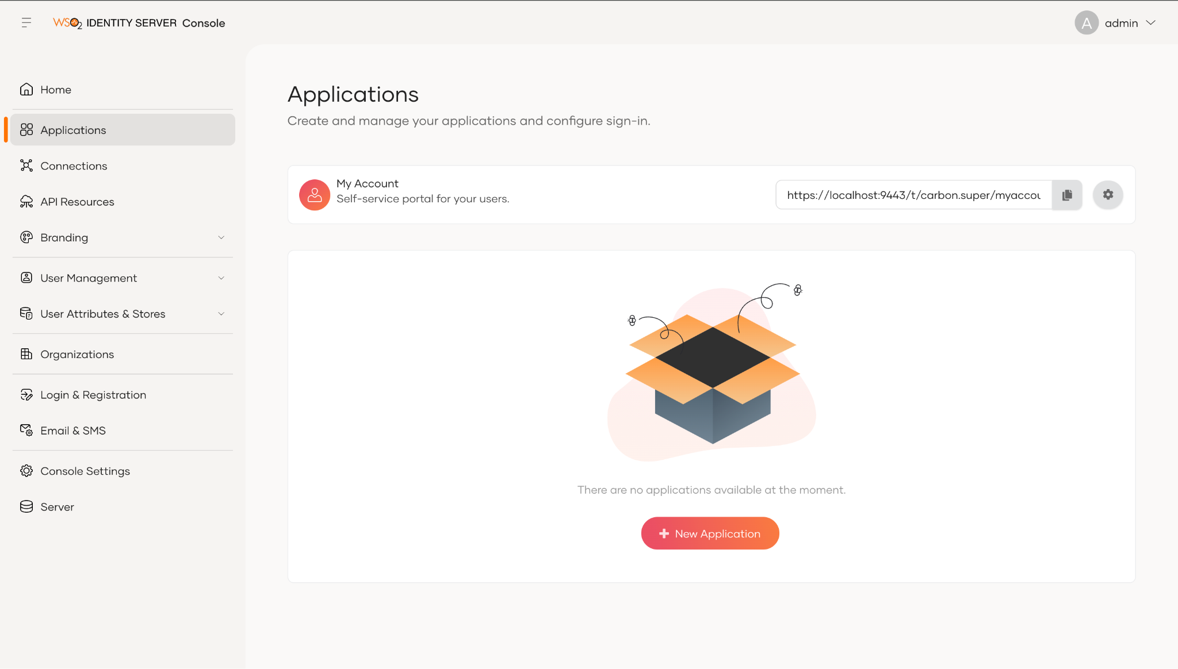
- Click New Application.
- From the given set of templates, select Traditional Web Application template.
- Fill the fields in the create application wizard.
Name: Pickup Dispatch
Protocol: SAML
Issuer: saml2-web-app-pickup-dispatch.com
Assertion consumer service URLs: http://localhost:8080/saml2-web-app-pickup-dispatch.com/home.jsp
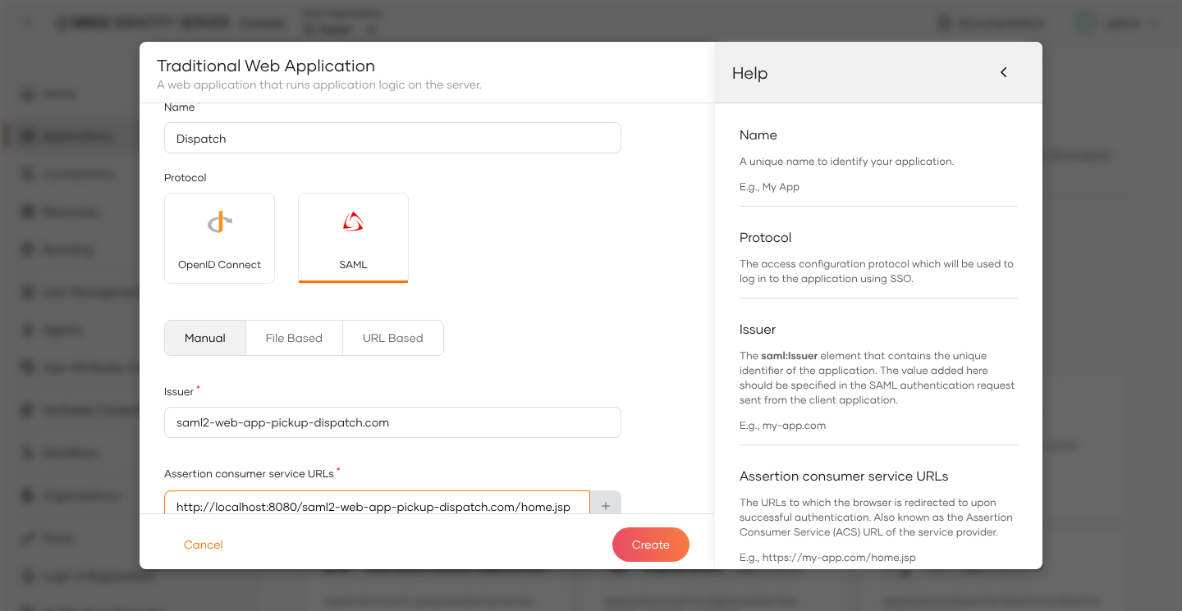
- Click Create.
- Goto the Protocols tab and click on the check box to Enable Response Signing.
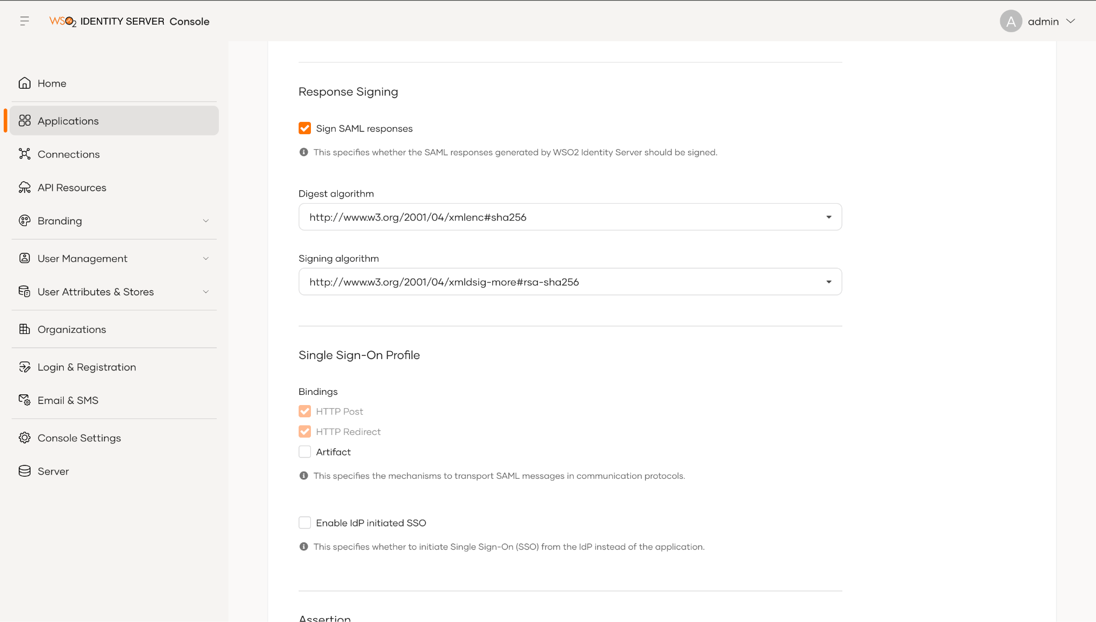

- Next, repeat the same steps 3-7 to create a new service provider for pickup-manager application. Use the below values for the required fields.
Name: Pickup Manager
Protocol: SAML
Issuer: saml2-web-app-pickup-manager.com
Assertion consumer service URLs: http://localhost:8080/saml2-web-app-pickup-manager.com/home.jsp

- Now you are ready to try out the sample with SAML SSO.
- Restart the WSO2 Identity Server.

Try It:
- Go to http://localhost:8080/saml2-web-app-pickup-dispatch.com and click on the login button.
- You will be redirected to the login page of the WSO2 Identity Server. Log in using your user credentials.
- You will be redirected to saml2-web-app-pickup-dispatch.com application home page.
- Now if you go to http://localhost:8080/saml2-web-app-pickup-manager.com, and click the login button, you can see that the user has automatically logged in to this application.

